**Touchscreen on ATMs**

Table of Contents

1. **Troubleshooting summary and hotfixes2**
2. **Testing on administrator3**
3. Calibration
4. Tablet PC input
5. Kiosk.ini
6. **Hardware issues9**
7. **Troubleshooting and fixes:**

When troubleshooting issues with touchscreen you will need to have a staff member next to it. It is best to ask for mobile phone when logging a new call for ATM touch and managers help.

**Check how touch option performs on administrator when using paint**

1. **Is it recording touch but is not aligned properly?**

Solution:Calibrate it using ELO software

(check part 2 Testing on administrator, section a) calibration)

1. **It is recording touch, showing white circle on point touched, however won’t interact with software on screen.**

(Solution: check part 2 Testing on administrator, section b) Tablet pc input)

1. **It works fine on administrator but not on vista.**

Solution: Change “AutoClickNavigation=” in Kiosk.ini to opposite value than it is currently set (“N” to “Y”).

(Check part 2 Testing on administrator, section c) Kiosk.ini)

1. **Won’t record any touch or is completely black**

(Check section 4. Hardware issues)

1. **Testing on administrator**

If the touchscreen is not responsive:

Re-log to administrator

Open paint and ask person on the other end to draw something trying to cover as wide area of the paper as possible:

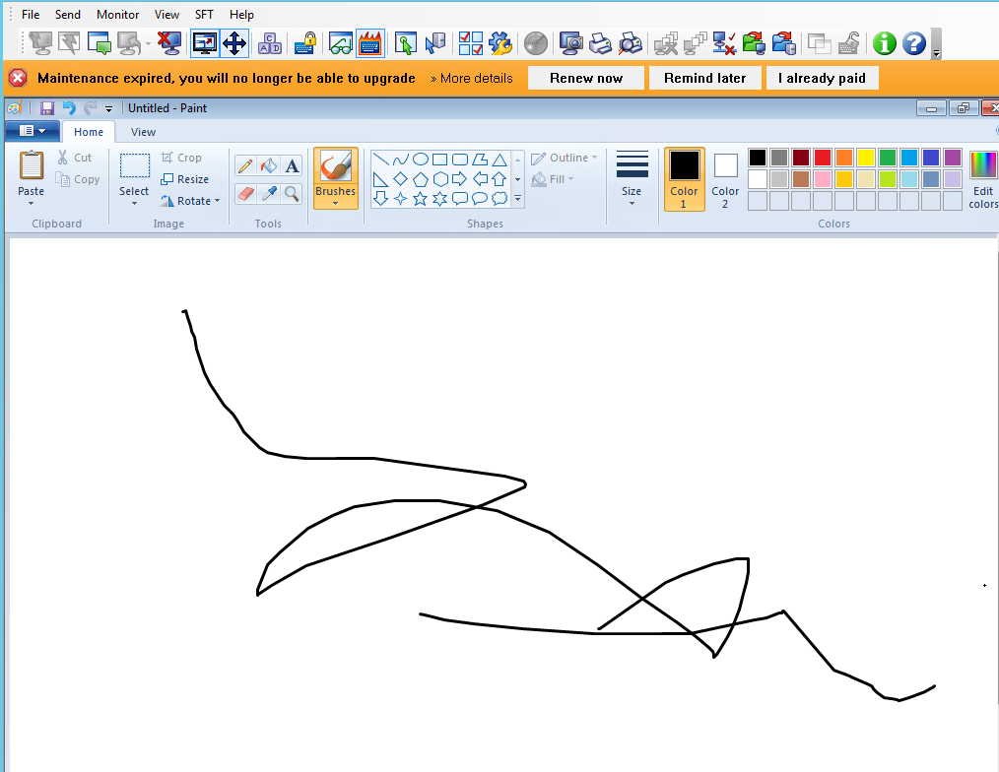

There may be 4 different outcomes for this test:

1. **If the screen is not calibrated properly/ there is a gap between point touched and point recorded on the screen- calibrate the screen**

Calibrate the screen by clicking ELO icon in right bottom corner of the screen, select align and run the calibration.

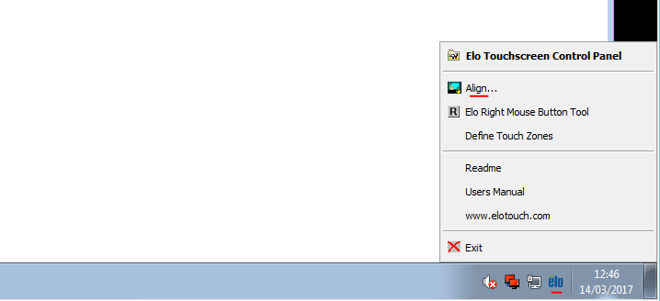

Cross hair on the screen should be touched and pressed by a finger.

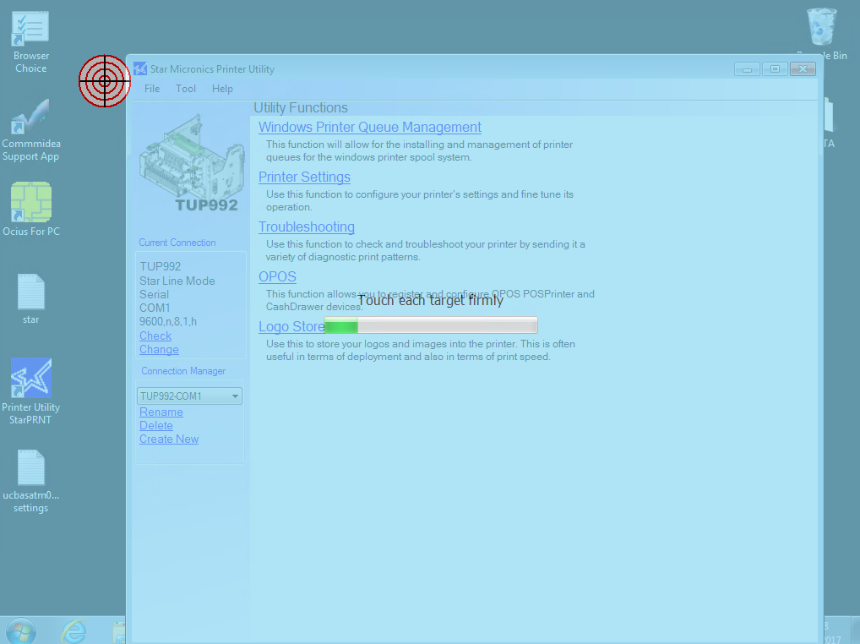

After calibrating reboot the ATM.

**b )If the screen does not record any commands on the software (it won’t leave a mark on paint for example) however you will see the screen reacting to touch in the place touched (very often there will be a white circle appearing around the place touched)**

**Fallow the fix bellow:**

Go to services-> Find “Tablet PC Input Service” and restart it

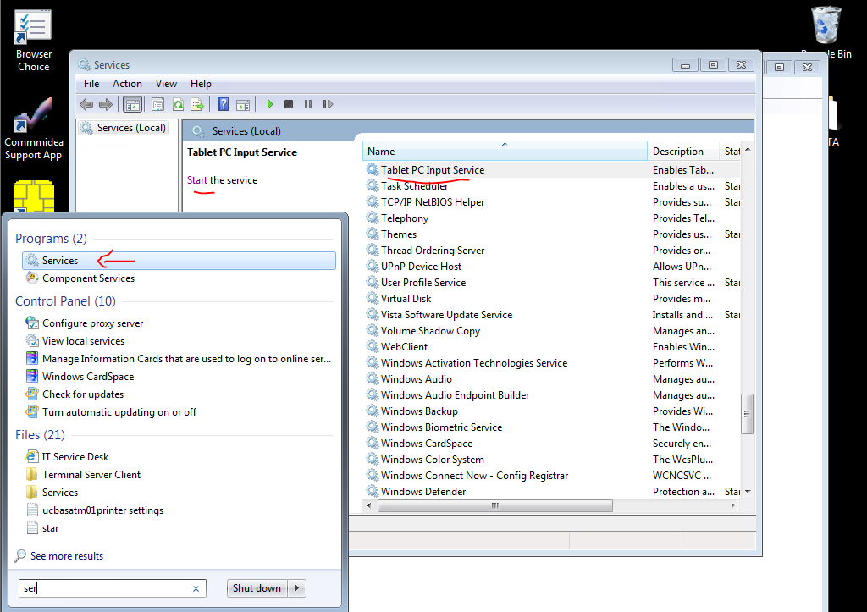

1. **Touchscreen works perfectly on administrator, however it will still be not responsive on vista.**

**Go to C:\VISTA\VistaKiosk\Config, and open KIOSK.ini**

**Under [Appearance] check the last string “AutoClickNavigation=Y”**

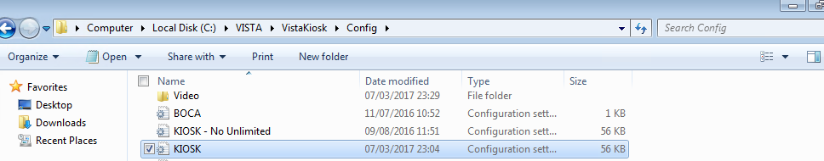

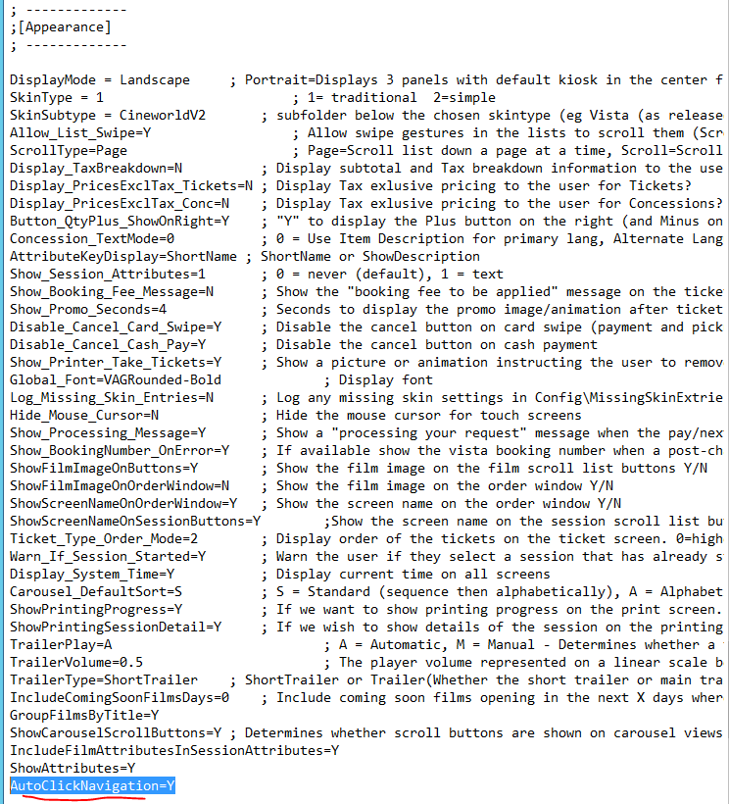

**If “AutoClickNavigation=” is set to “Y” change it to “N”**

**Adding this version may help if it is absent from kiosk.**

**However on some versions of vista it will cause troubles (example West India Quey).**

1. **Touch is not responding at all- check next section 4. Hardware issues.**

**3.** **Hardware issues**

**Touchscreen is black**

**You should narrow down the issue by investigating with manager:**

1. **If there is power is NOT going to ATM.**

If this is only the touchscreen issue, you should be still able to dial in to the atm and see the config/ vista running.

If not this may be:

-Issue with the power socket

*Solution: ask manager to check if he can for example charge the phone using this socket. Fixing power socket issues should be done by the cinema (asking a engineer to fix it)*

- Issue with the PSU

*Solution: May be disconnected, ask manager to reconnect it.*

-Issue with the base unit- If all other modules like PED/printer are powering on but the base unit is not booting.

*Solution: If it’s not powering on and you are sure PSU is plugged correctly- this is base unit issue.*

1. **If there is power going to ATM:**

-ATM touch is not responding.

*Solution: ask manager to replug USB cable*

-Touchscreen is blank but you can dial in to ATM. Also there is power going to screen, but no content.

*Solution: ask for DVI cable to be replugged*